Powered Wheelchair Referral Form
REWS (Rotherham Equipment & Wheelchair Service)

This form should be completed and signed by the patient’s Doctor AND Healthcare Professional
Please complete ALL sections fully. Failure to do so will result in delays processing the request.
Please note we do not provide scooters.

Patient’s Personal Details
Title |  | Gender | Male Female
Surname
Forename(s) |  | Date of Birth
Preferred Name |  | NHS Number
Home Address |  | Delivery Address
Post Code |  | Post Code
Tel No. |  | Contact
Mobile No. |  | Tel No.
Email Address |  | Main Language
Ethnic Origin |  | Religion
Disability
Relevant Medical Details
Critical Case (e.g. terminal illness) Yes No
Essential for hospital discharge? Yes No Date
Is this person already in possession of an NHS wheelchair? Yes No

Details of GP
Name |  | Address
Tel No.
CCG |  | Post Code

Details of Prescriber
Print Name |  | Address
Tel No.
Profession |  | Post Code
Would you like to be present at the assessment? Yes No
Signature |  | Date

Assessment Details: Wheelchair
What is the person’s walking ability within the home?
What is the person’s transfer method?
How often will the wheelchair be used?

Assessment Details: Cushion
Is a standard foam cushion adequate? | Yes No If yes:
Suggested cushion?
What is the maximum duration the person
will sit in the wheelchair in one session?
Can the person maintain sitting balance in the wheelchair? | Yes No
Person’s tissue status:
Previous sore(s): Yes No | Present sore(s): Yes No
Site Grade | Site Grade
Continence status:
Who will maintain and monitor cushion? | Waterlow score

Assessment for Powered Wheelchair
Assessment required for indoor powered wheelchair? | Yes No
Assessment required for indoor/outdoor powered wheelchair? | Yes No
Accessories required:
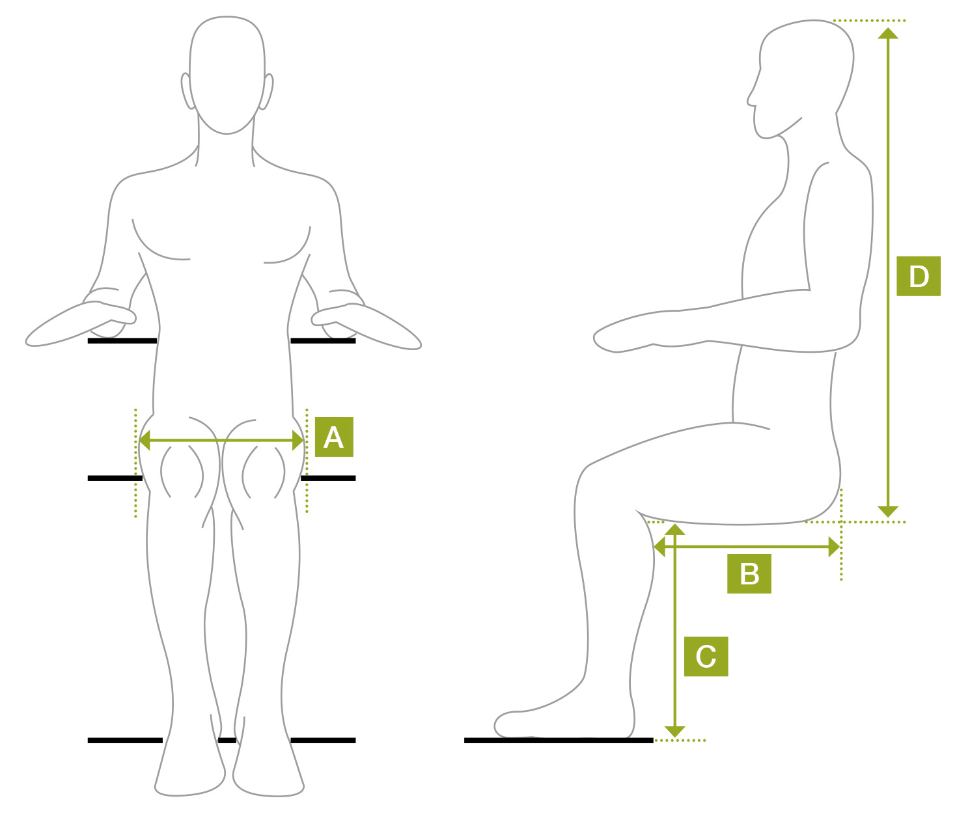
Measurements
Height
Weight
A = Hip width | cms  ins
B = Back of buttocks  to back of knee | cms  ins
C = Back of knee to sole  of foot | cms  ins
D = Seat to top of head | cms  ins

Further Assessment by REWS Centre Team Will Be Required
Is further assessment required by REWS? |  | Yes No | Interested in Personal Wheelchair Budget? | Yes No
Referrer would like to be present at assessment? |  | Yes No
Referr’s Comments

Please Forward to Patient’s Doctor Before Submitting to REWS

Section for Doctor to Complete
Please complete the request for medical information, which is needed before an assessment can be arranged for a powered wheelchair for your patient.
Please tick the selected answer.
1. Mobility: In your opinion, is this person unable to walk or self propel  a manual wheelchair, or are they medically at risk to do so?  Comments:? |  |  |  | Yes No
2. Is this patient affected by the following?:  A. Epilepsy/blackouts  Has the patient had a seizure in the past year?  B. Any medication or their side effects:  Comments:?  C. Visual impairments  Please give details:  D. Mental health problems (relevant to safe wheelchair use)  Comments:?  E. Perceptual deficits e.g. neglect  F. Any other conditions that may affect safe use of a powered chair?  Comments:? |  |  |  | Yes No  Yes No  Yes No  Yes No  Yes No  Yes No  Yes No
3. In my opinion, this individual is medically fit to control an EPIC  (Electrically Powered Indoor wheelchair) |  |  |  | Yes No
Doctor’s Signature |  | Print Name
Date

PLEASE RETURN TO:
Rotherham Equipment Wheelchair Service
Eastwood Trading Estate
Chesterton Road
Rotherham
S65 1SX
Tel: 01709 916889
Fax: 01709 263296
Email: cabsl.rotherhamwheelchairservices@nhs.net

